Medical Insurance

Python.file:

Screenshot:

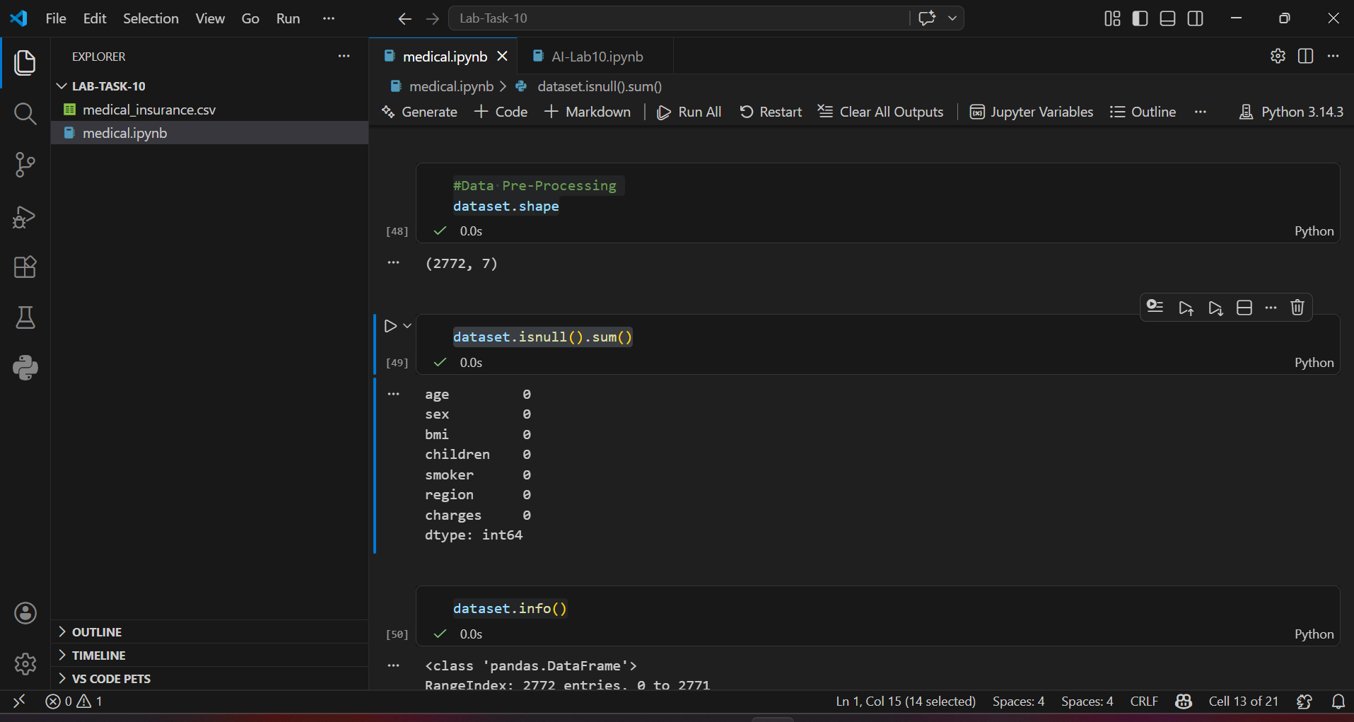

Details:

1. Importing Libraries
We imported necessary libraries such as Pandas and NumPy to handle and process the dataset.
import pandas as pd
import numpy as np

2. Loading the Dataset
The dataset was loaded using Pandas:
dataset = pd.read_csv("medical_insurance.csv")

3. Exploring the Dataset
We explored the dataset using different functions:
- dataset.head() → to view first 5 rows
- dataset.tail() → to view last 5 rows
- dataset.shape → to check number of rows and columns
- dataset.columns → to display column names
- dataset.info() → to get dataset summary
- dataset.describe() → to get statistical summary

4. Checking Null Values
We checked missing (null) values in the dataset:
dataset.isnull().sum()

5. Handling Null Values
We handled missing values by filling them with the mean (average) of their respective columns.
columns = ['bmi', 'children', 'charges']
for col in columns:
dataset[col] = dataset[col].fillna(dataset[col].mean())
This ensures no missing data remains in important columns.

6. Changing Data Types
We converted column data types to integer for better processing:
dataset['children'] = dataset['children'].astype(int)
dataset['charges'] = dataset['charges'].astype(int)
dataset['bmi'] = dataset['bmi'].astype(int)

7. Saving the Cleaned Dataset
After preprocessing, we saved the cleaned dataset:
dataset.to_csv('medical_insurance_cleaned.csv', index=False)

